Monthly Report for April 2020
Lower Milford Township

Call Volume

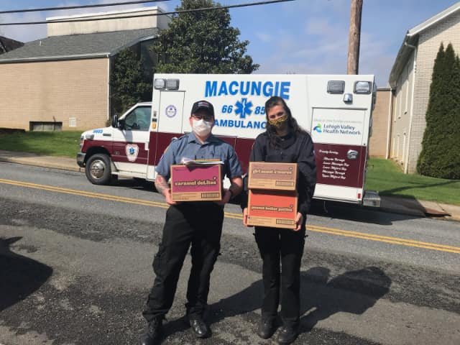
The Macungie Ambulance Corps responded to 259 calls for service this month. This is the lowest monthly call volume recorded in the last 3 years.

2 of those calls were in Lower Milford Township.

While we were busy on other incidents, our mutual aid partners responded to 0 calls for assistance in Lower Milford Township this month.

Other Points of Interest

The COVID-19 pandemic has remained the primary focus of our organization’s activities over the past month. We continue to respond to emergency calls for service and maintain our usual staffing levels. At the current time, we are happy to report that we are fully staffed and none of our members have experienced illness related to the pandemic.
We continue to respond to emergency calls as previously noted utilizing enhanced safety precautions. We have no unmet needs at this time and the generosity of the community has been appreciated.
We also continue to urge community members and leaders to continue following CDC and state guidelines and orders.
Our organization, along with many other EMS agencies and healthcare providers, saw a substantial decrease in call volume during the early phases of the pandemic. For our organization, call volume in March was 16% lower in 2020 compared to 2019. For April, that reduction has stabilized somewhat and was only 11%. This is a much smaller decrease than several other local EMS organizations.
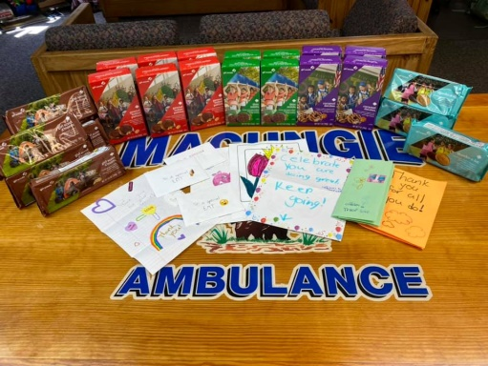
Local health networks and our organization want to remind the public that emergency services are still safe and available. We hope nobody ever has to use our service, but we certainly don’t want people to be afraid to call 911 either. Ignoring symptoms of serious illness or delaying emergency care can have significant negative consequences. Rest assured, our organization remains able to respond safely to emergencies as they arise.
Thank you all for your ongoing support and Be Well!

